HEALTH CHATBOT
Name : Ian Ngige karonji
Email: iankaronji3192@gmail.com
school: murang’a university of science and technology
GitHub: https://github.com/Vegas254/health_chatboot
Submission Date: February 22, 2026
1. Overview
An AI-powered backend application called the Health Chatbot was created to respond to inquiries about health. Users can communicate with an intelligent assistant through the system, which responds with context-awareness. The chatbot integrates a Large Language Model (LLM) using Groq and LangChain, uses MongoDB for memory storage, and develops APIs using FastAPI.
2. Utilized Technologies
The Use of Technology
Python is a core programming language.
Framework for developing FastAPI APIs
Chat history is stored in MongoDB.
Prompt LangChain and LLM administration
Integration of the Groq API AI model
Validation of Pydantic Data on the Uvicorn Development Server.
3. The System Architecture
• The user includes their question and user_id in a POST request.
• The system retrieves previous chat history using MongoDB.
• The AI model processes the new question, history, and system prompt.
• The assistant generates a contextual response.
• Both the user message and the response contain timestamps.

4. Implementation of MongoDB Memory
The chatbot stores conversations in a MongoDB database. Each message contains the following information: user_id, question, response, role (user or assistant), and timestamp. Every time a user sends a new message, the system retrieves previous entries, arranged chronologically, and passes them to the AI model to maintain context.
5. Endpoints for APIs
.GET / - Returns a greeting.
<code>
@app.get("/")
def read_root():
return {"message": "Welcome to the fitness assistant API"}
.POST /chat: Provides an AI response after accepting the user ID and query.
<code>
@app.post("/chat")
def chat(request: ChatRequest):
history = get_user_history(request.user_id)

response = chain.invoke({
"history": history,
"question": request.question
})
6. Launching the Program
Use pip install -r requirements.txt to install dependencies.
Use uvicorn app:app --reload to launch the application. I have attached the screenshoots of the project when live in this pdf .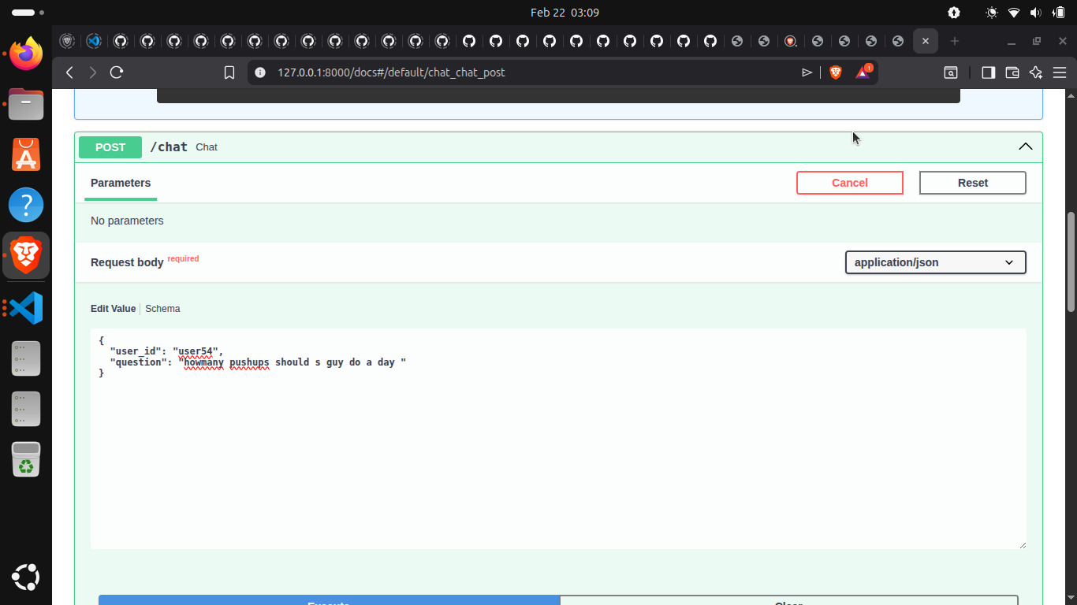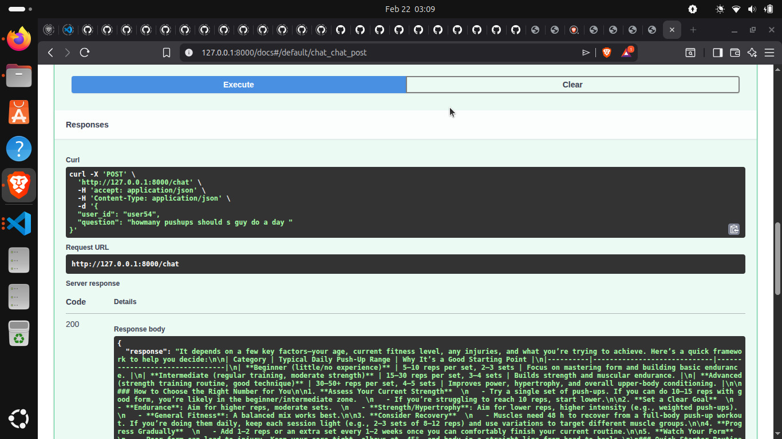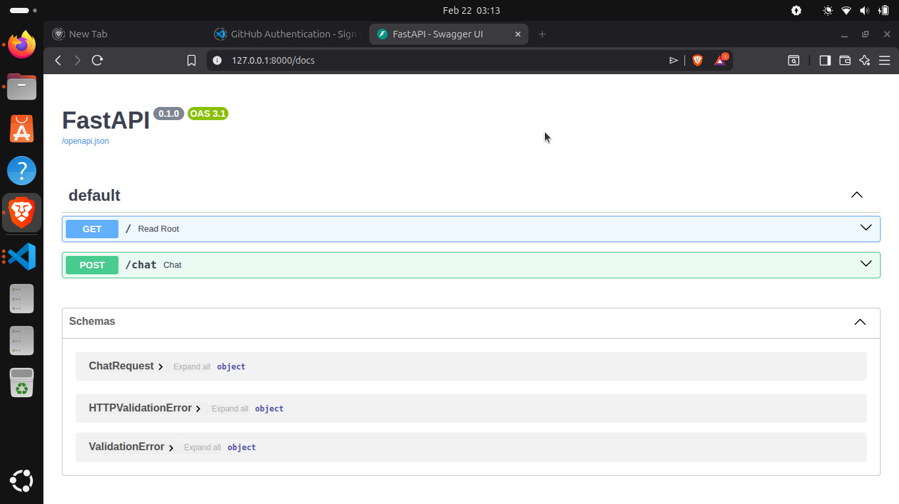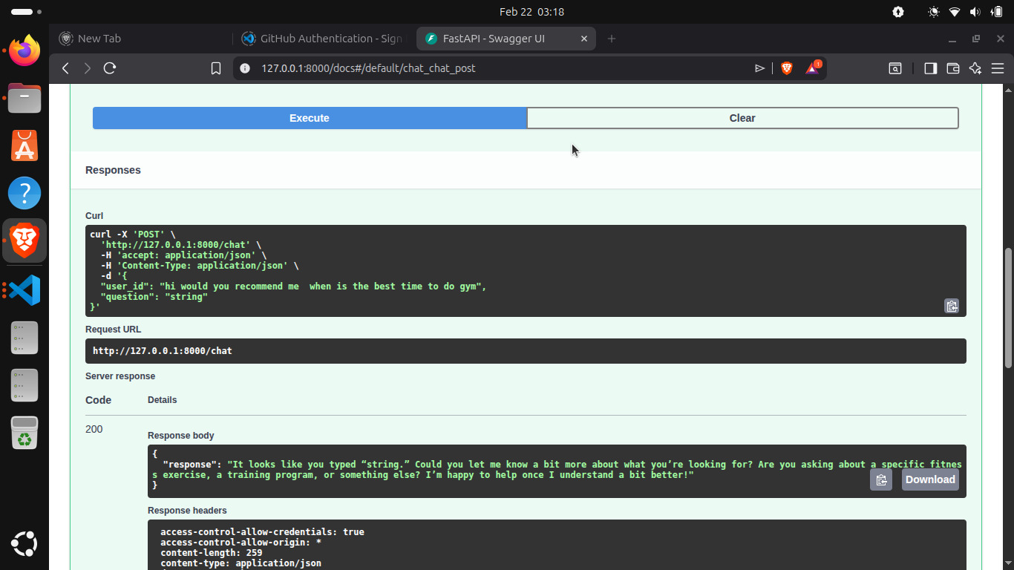
7. Conclusion
The Health Chatbot project showcases database integration, backend API development, and conversational systems driven by AI. It demonstrates how stored memory is used by AI assistants in the real world to preserve context. A frontend interface, authentication, or more sophisticated health knowledge sources could be added to this project.

